**Tutorial on Photoshop Basics for First Time Users**

By: Oliver Zavala

This tutorial will teach you the basics of Photoshop you need to know and also how to create a layout in which you can insert in your app or website.

1. 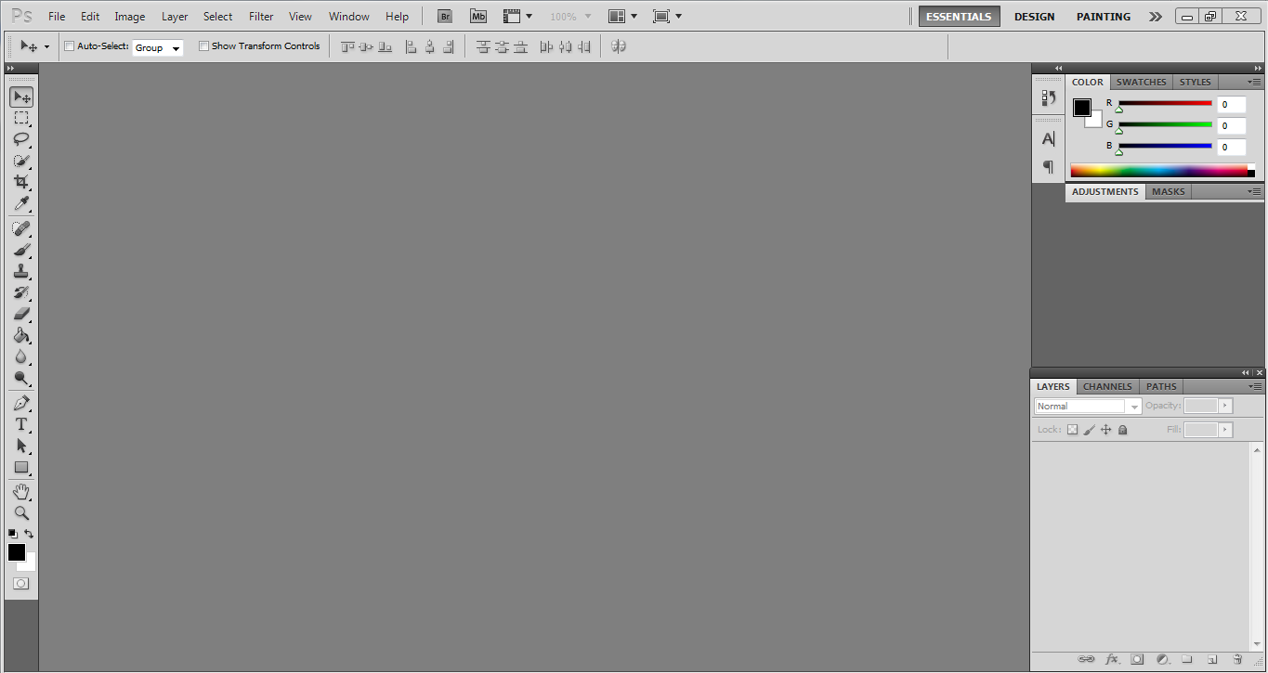Once you open Adobe Photoshop, you will get this screen:
2. In order to create anything from scratch, you must create a new blank layout or canvas to work on your design. To create a new canvas, go to **File > New.**

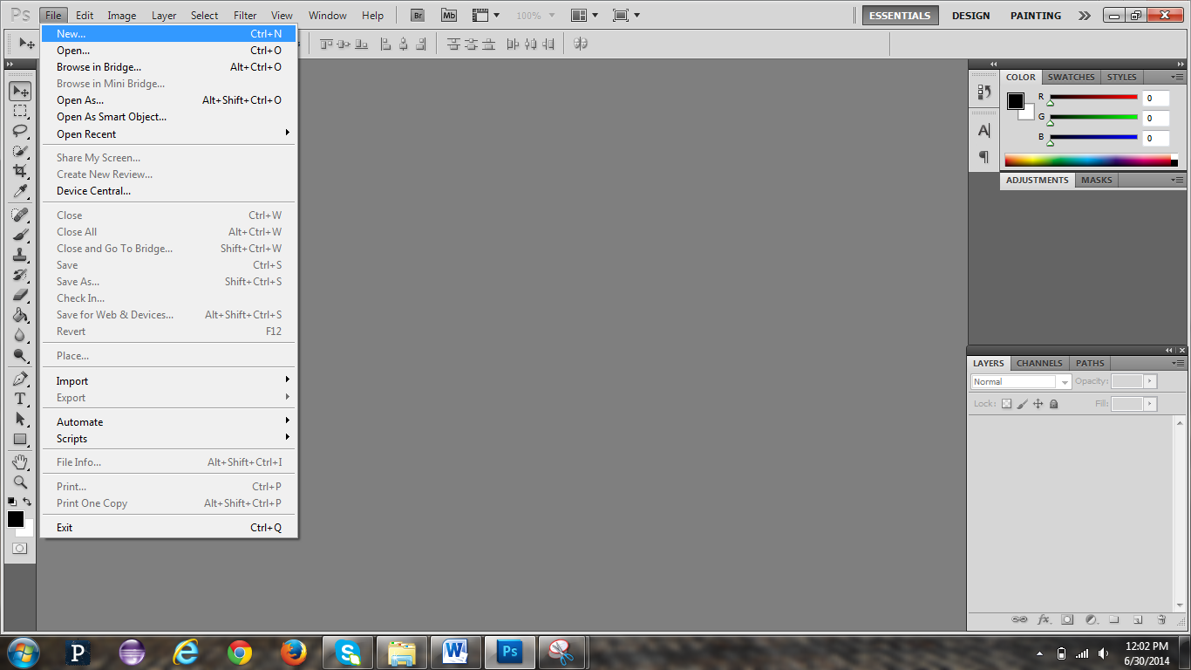

1. 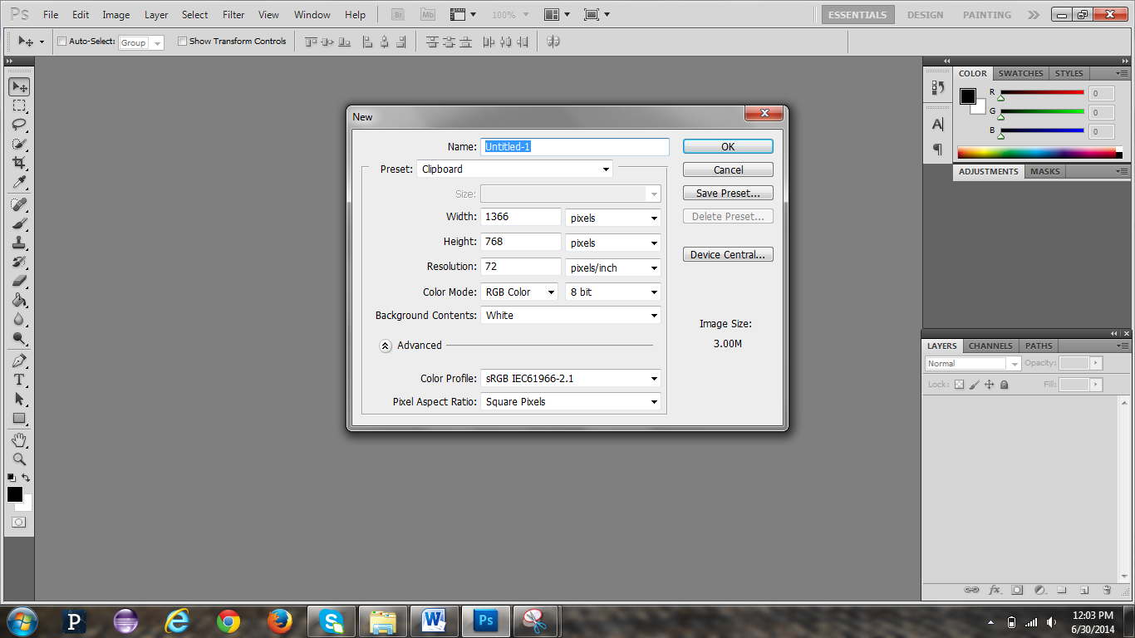Once you click New, the ‘New’ Window will appear, just like in the screenshot below. Here you can adjust the size of your working area. You may rename your new canvas.
2. However, if you are creating a design to be used on a mobile device, go to Preset > click on the drop down box and select Mobile & Devices. You may rename your canvas.

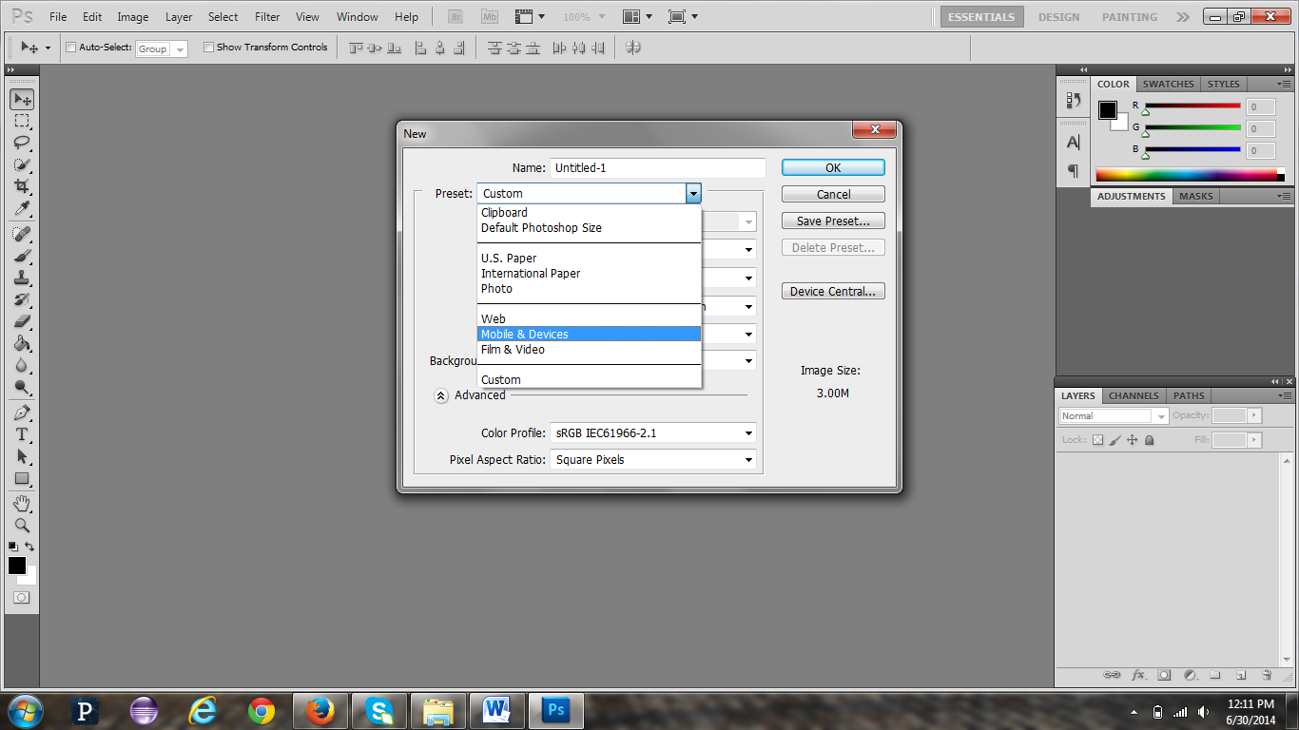

1. Since I am going to show you how to make a template and button that will be on a mobile device, we will choose 'Mobile & Devices' and click OK.
2. 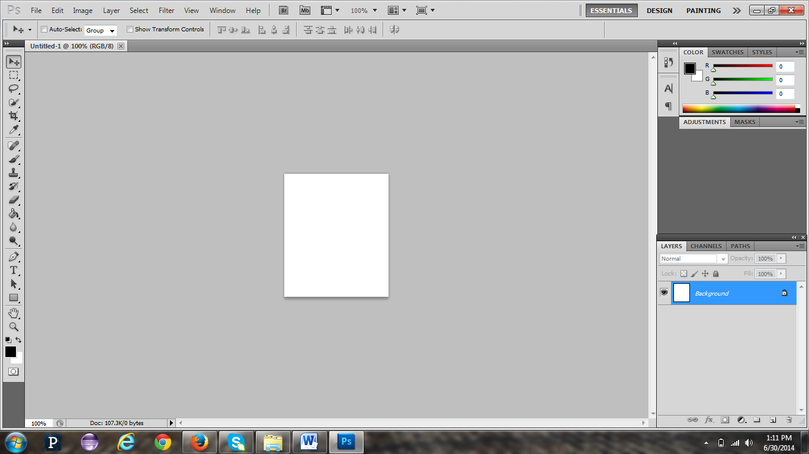After you have clicked OK, the new canvas will open, just like in the image below.
3. Since it looks a bit small, let’s zoom in. Look in the bottom left. See the percent number? For me, it's 100%, but for you it may be different.

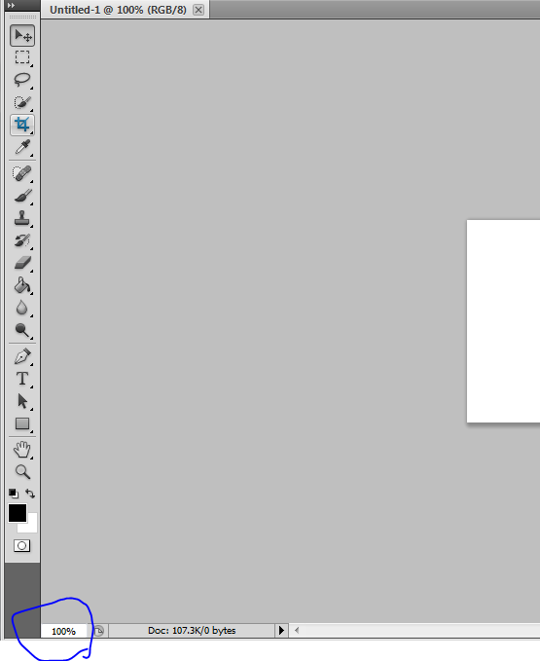

1. Double click on the percentage number (for me, it is 100%). Then type in the number 280 and hit the Enter. You don't need to type in the % sign, as it will automatically put it in for you.

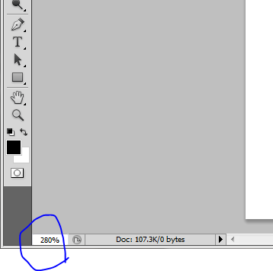

1. You will now see that it zoomed in and you will be able to see the canvas larger. You can always change the zoom percentage to zoom in or zoom out by changing the percentage value.
2. 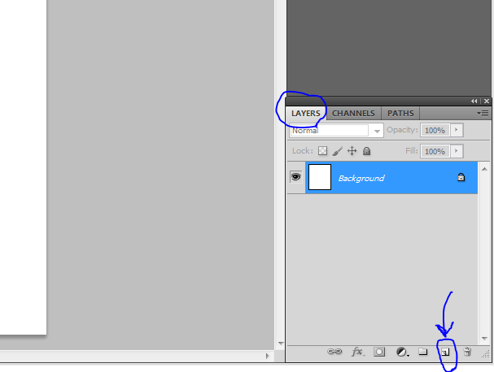Now let's start by creating a new layer. Layers work like papers. The background would be like a blank sheet of paper on a table. If you add a layer, it would be like adding a transparent sheet on top of the blank sheet of paper. We must add a new layer so that we can do our layout and button from there. If you don't see the layer's panel, like in the image below, then go to STEP 11. On your layer's panel, click the icon next to the trash can. This icon says 'create new layer'.

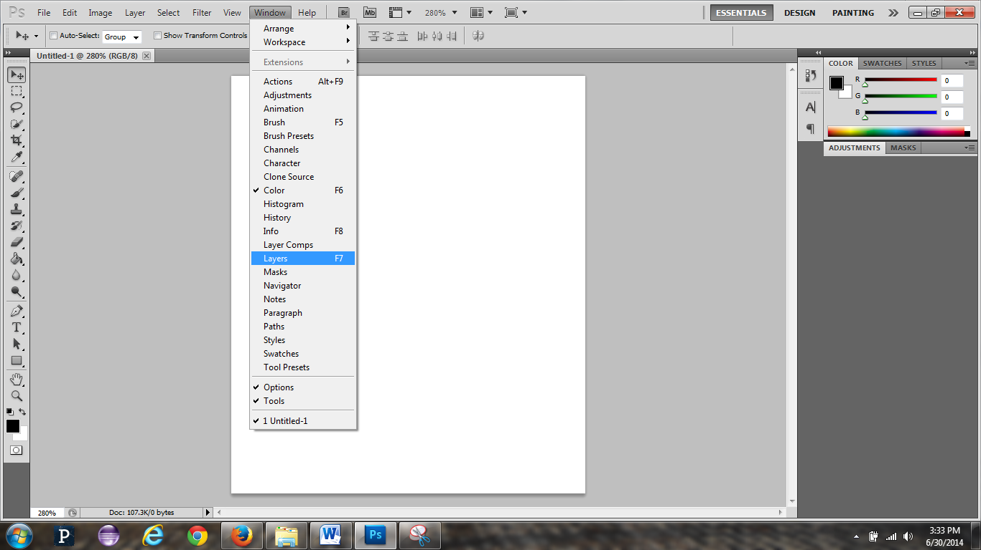11. THIS STEP IS ONLY IF YOU DON'T SEE THE LAYERS PANEL. If you do see the layers panel, then go to STEP 12. If you don’t see the layers panel, go to Window and then click on Layers. Please see the image below for reference. Once the layers panel appears go back to STEP 10 to create the new layer.



1. We are going to first start with creating a layout that will include a picture and some text. There are many different ways on how to create a layout, depending on your purpose of creating one and your creativity. We will create a basic one so you can have an idea of what tools we are going to use.
2. I would like to create something that is marine related, so I'm going to use blue colors. Let’s start by clicking once on 'Layer 1' in the layers panel. Then, we are going to go to the tools section, and select the 'rectangle tool' (see picture). You may need to right click on each icon until you find and click the one that says 'rectangle tool'.

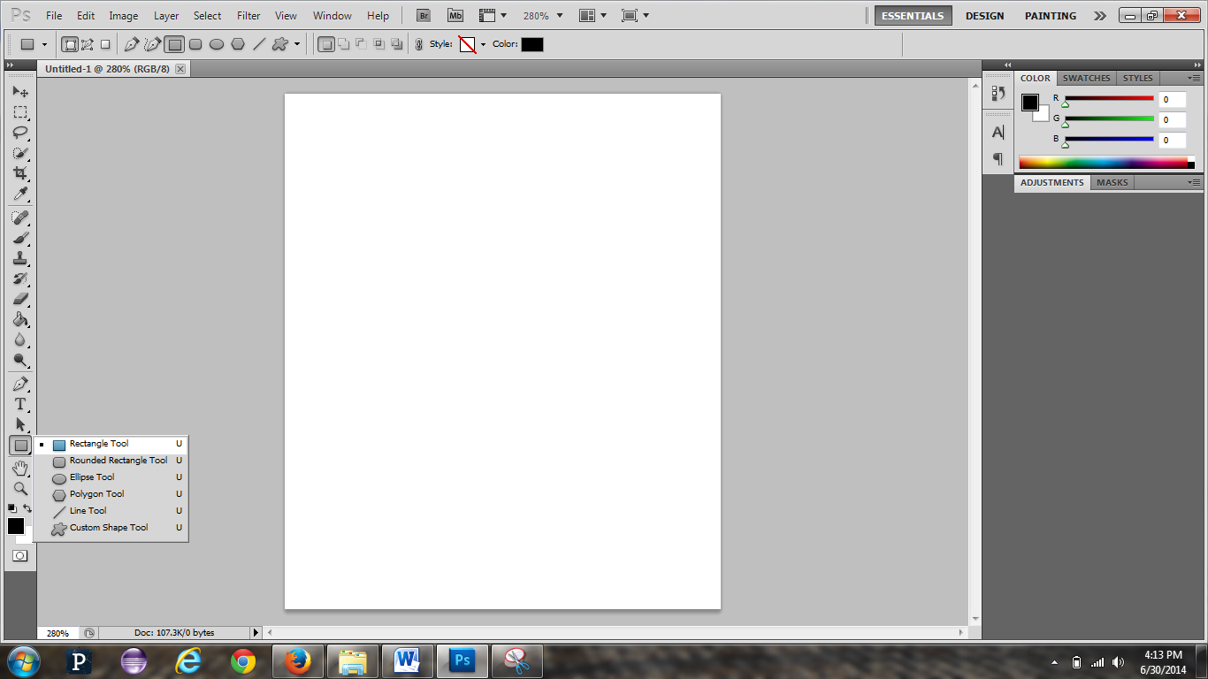

1. Now we are going to choose the color of the new shape we are going to create. I am going to choose a marine blue, but you may choose whichever color you desire. Simply click once on the black square and the color picker with come up.

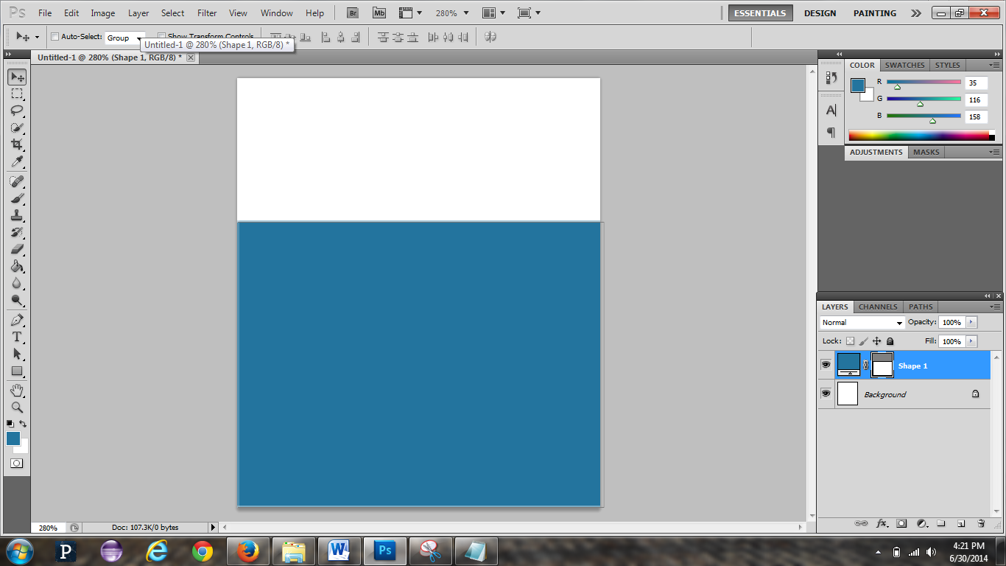

1. After you have chosen your color, click Ok. The color has now been chosen and you may draw the rectangle just like you see it in the image. If you drag your cursor into the canvas (the white sheet), you will see a + (plus) sign. This means that Photoshop is ready for you to draw the shape.

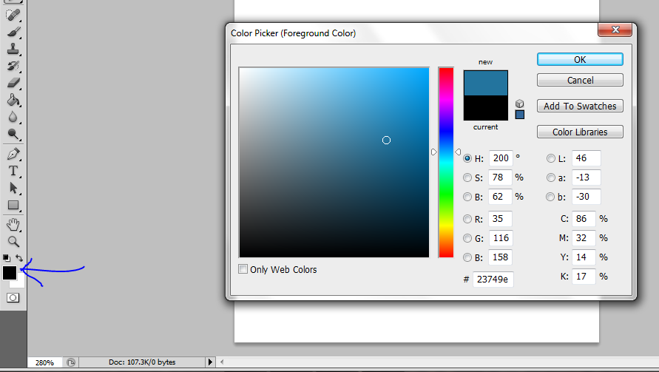

1. 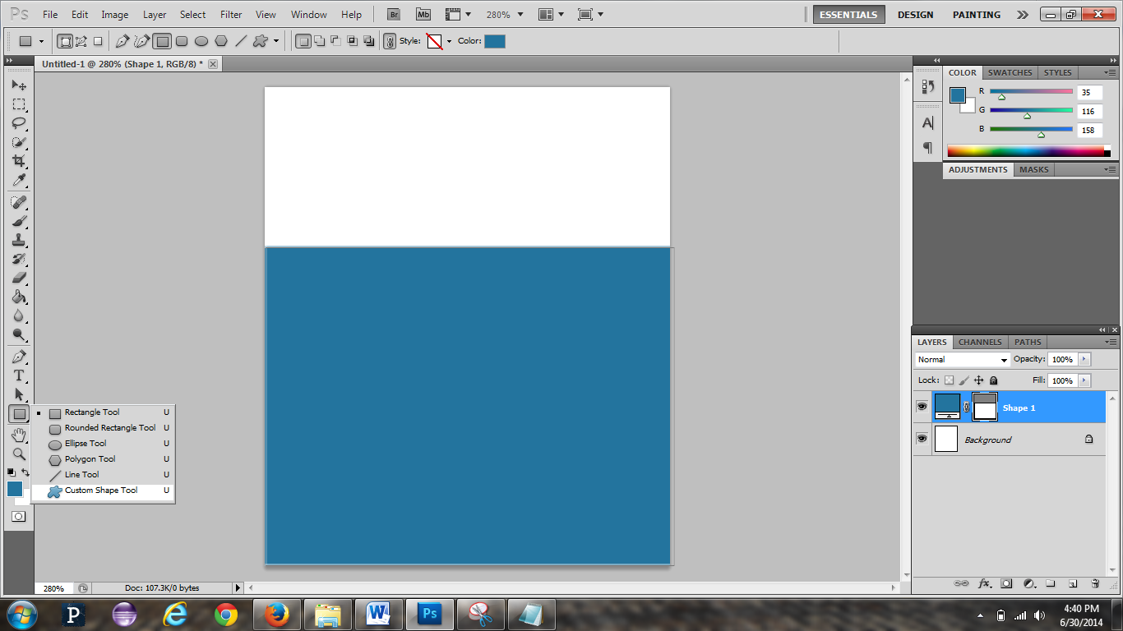After you have done that, you can add custom shapes. In this one, I will add preset squiggly lines which would represent the waves. In order to see all the custom shapes they have available, we will have to right-click on the 'rectangular tool', the one we used to make the huge square. After you right click it, search for 'custom shape tool'. Click it.
2. 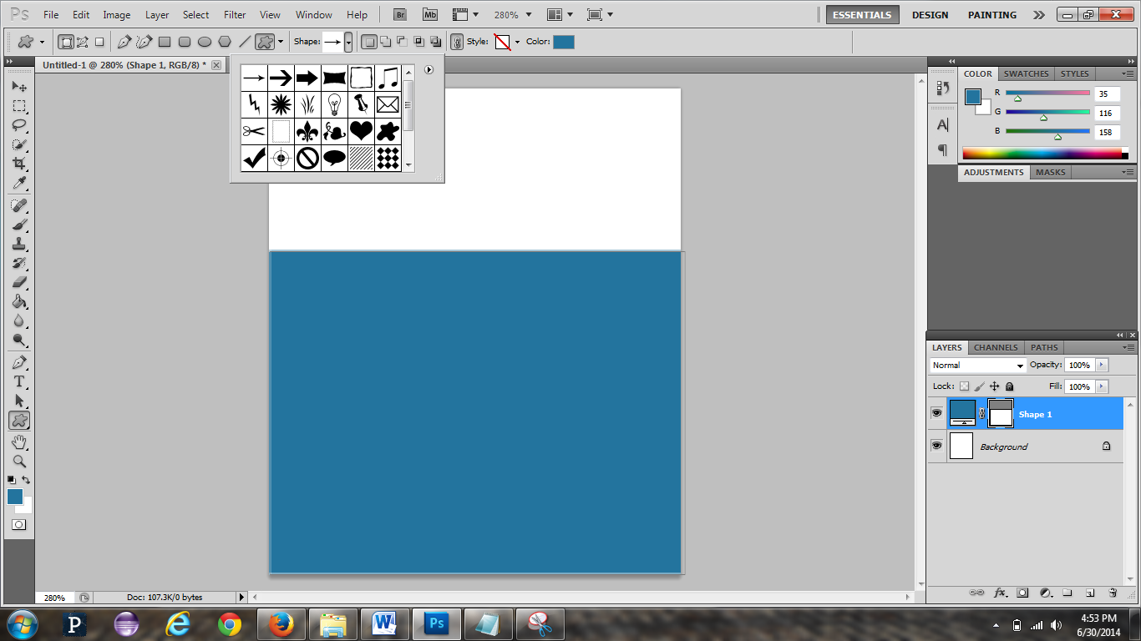Now go to the top and see the star figure with the drop down arrow? Click the arrow. A box will different shapes will appear.
3. Now click on the arrow facing towards the right and then choose ‘All’.

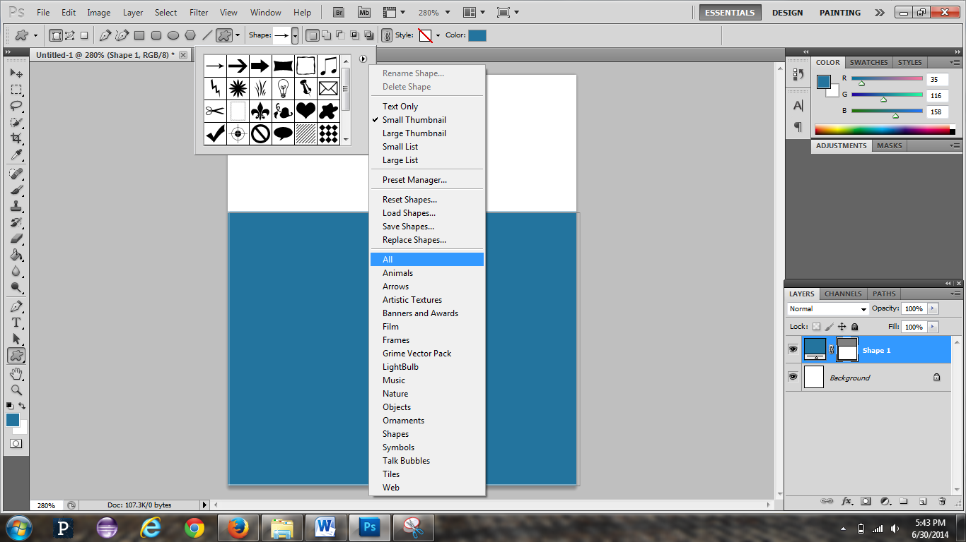

1. A sign will appear like in the image below. Click OK.

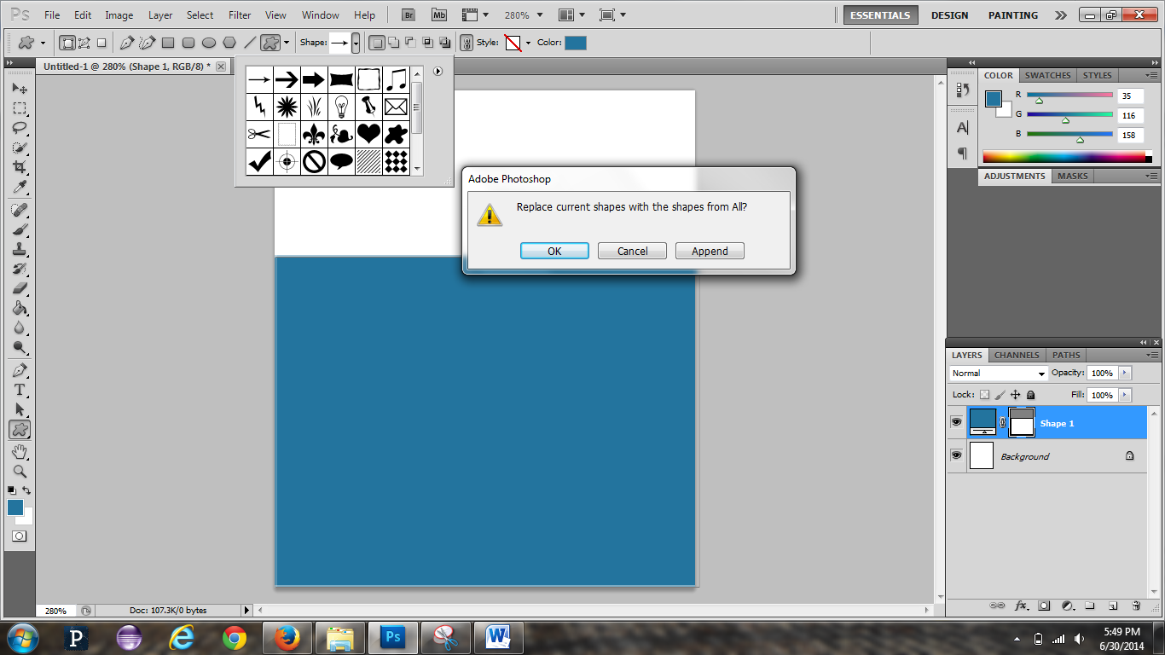

1. I will then choose the shape, which in this case would be the squiggly lines from the box, but you may choose whichever shape you would like. However, before I even start inserting it into my canvas, I will add a new layer. This way, I can customize the color of my new squiggly lines without changing the blue color of the large square we drew.
2. I will then choose the shape, which in this case would be the squiggly lines from the box, but you may choose whichever shape you would like. However, before I even start inserting it into my canvas, I will add a new layer. This way, I can customize the color of my new squiggly lines without changing the blue color of the large square we drew.

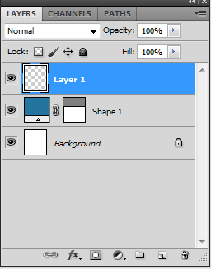

1. Now that I have my new layer, I don’t want my squiggly lines to be the same color as the square I drew. What I have to do now is to change the color of my squiggly lines. However, to change it I will have to click the color box on top, not the one on the bottom left. See the image below.

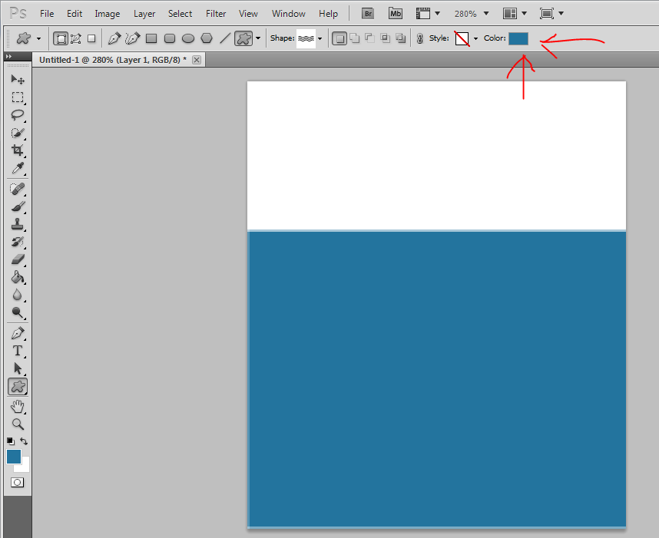

1. I have chosen my color already and drew the preset squiggly lines. Now, we are going to add an effect which will make the lines look bolder. We are going to use ‘Bevel and Emboss’.

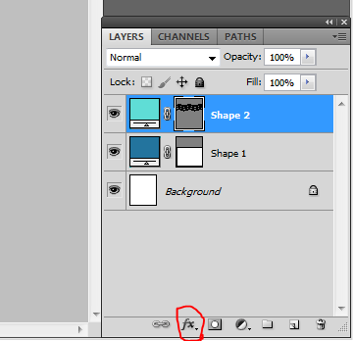

1. 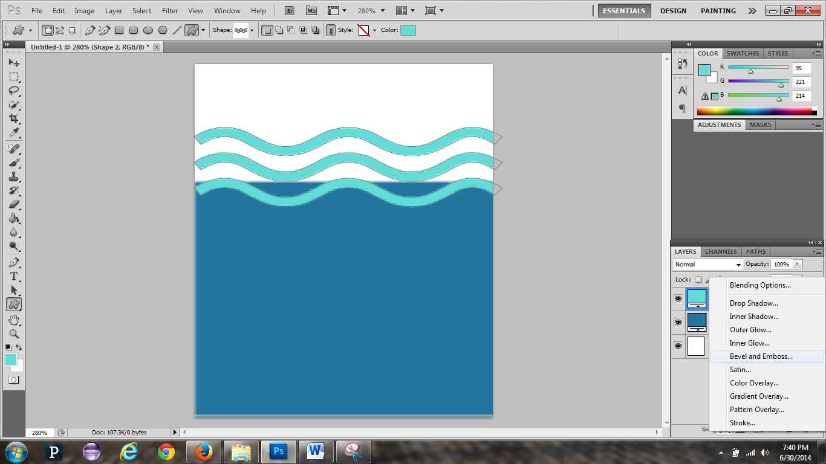Start by clicking on ‘Shape 2’ in the layers panel. Then go down and click where there is an icon that looks like a fx. This is the ‘add a new layer style’ button. After you click it, look for ‘Bevel and Emboss’ and click it.
2. After you have clicked it, the Bevel and Emboss window will pop up. Change the size to 24px and the soften to 6px. As you can see the tabs on the left side, you can modify other things to the image. For right now, we are going to just do the Bevel and Emboss.

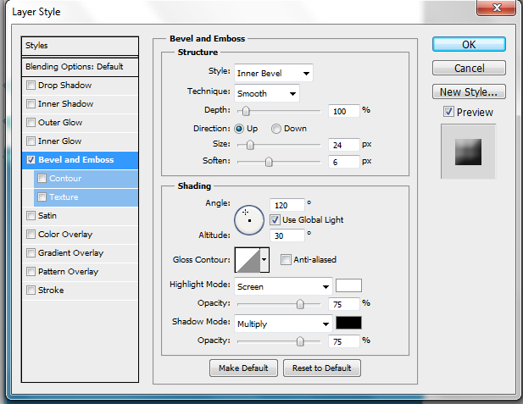

1. Click OK and you will see a change in the shape you choose (for me it’s the squiggly lines).
2. Now let’s add an image in the empty space. Go to File > Open. Choose the image and it will open it in a different tab.
3. Go to the tab where the image is and in the background layer, double click on the lock. A popup window will come up, just click OK.

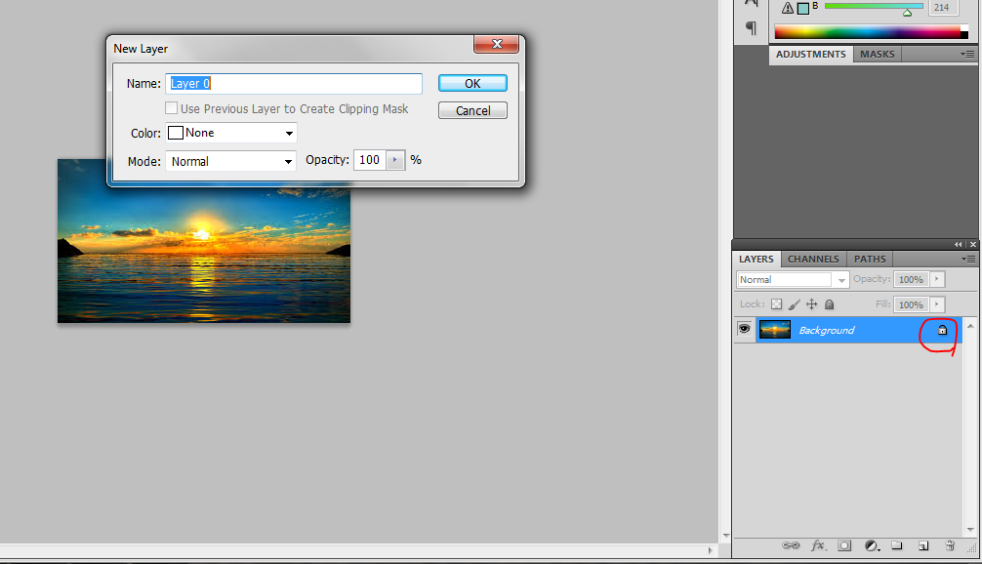

1. Now on your keyboard hit CTRL + A to select the whole picture. Then, go to Edit > Copy.
2. Now go back to the original canvas. Go to Edit > Paste. The image may come out to be very small or very large. As you may have noticed, Photoshop automatically makes a layer for the picture once it is in the canvas.
3. Whether it is too small or too big, you need to resize it. Make sure the picture’s layer is selected. Now hit CTRL + T. Then hold the SHIFT key and adjust the size of the picture. Do not let go of the SHIFT key until you are sure you are done adjusting the size. Holding the shift key prevents the image from being distorted while resizing.
4. Now, I would like the picture to be behind my squiggly lines and behind the large rectangle I made earlier. As you can see, the picture layer is on the top of the other layers. We want it to be behind the other layers, so we will drag the picture layer to the bottom on top of the background layer.
5. 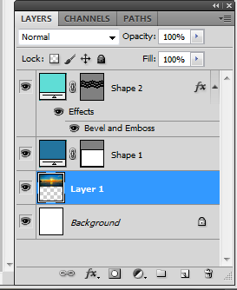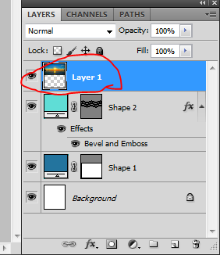Now that you have placed the picture layer on top of the background layer, on the canvas, in the tools section, choose this tool in the image below.



1. Now try to position the picture correctly so that it is visible. There should be not white space left.
2. Let’s add some text. Simply go to the tools section and choose the Text tool (it literally looks like a T). Even for the text, Photoshop creates a new layer. Photoshop is all about layers, but it makes it easier to work that way than without them (Microsoft Word doesn’t use layers).
3. Congratulations! You have just created your first template. You now know the basics and should be able to create a basic or if you can, a more detailed template!

PS: This is my final template. Yours may vary.

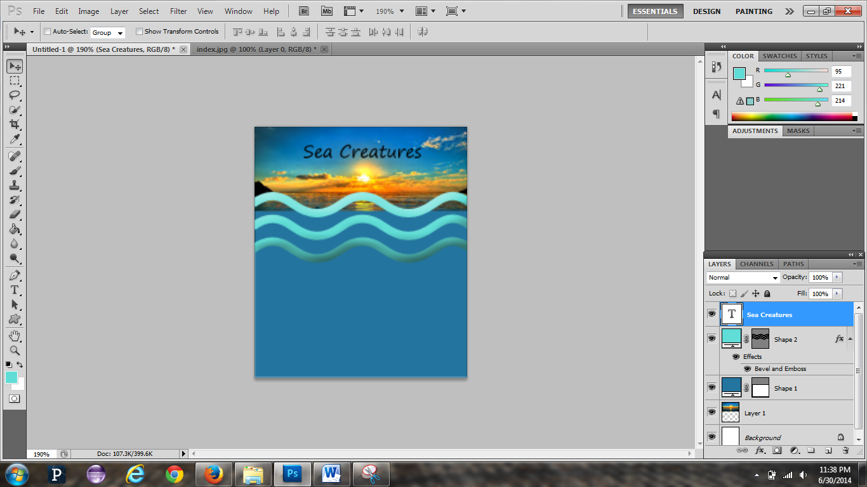

**TIP:** Should you ever do a mistake, you may go back to a time before you made the change/mistake using the history panel. Look below for instructions on how to do this.

How to get the History Panel

1. Go to Windows > History
2. You will see the History Panel. You may click on any of the changes you have done to bring it back to that time. Give it a shot!

